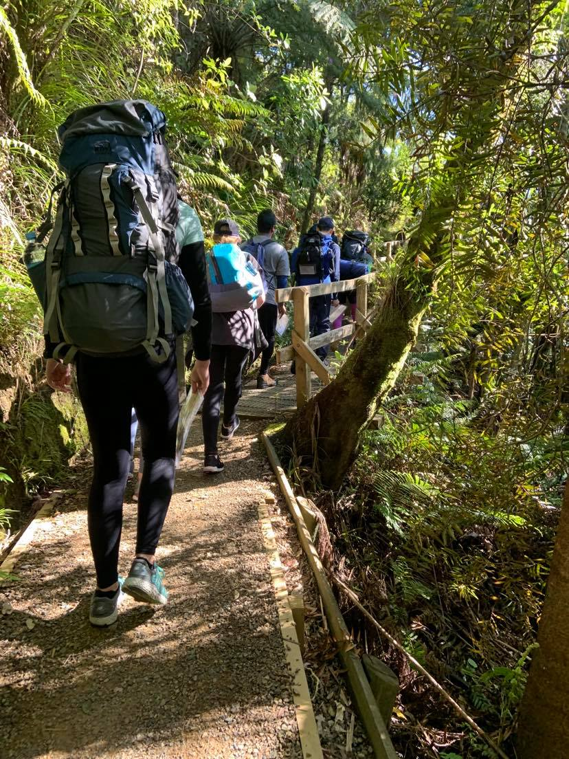
PART 2 | Requirements and responsibilities
DofE Journey Planning pack
The following information is excerpts from the Duke of Edinburgh’s International Award - International Handbook for Award Leaders. This sets out the official requirements and responsibilities for all journeys. Copyright for these excerpts belong to the Duke of Edinburgh’s International Award.
Annotations and notes are in footnotes

Definitions

Aim
The first thing that needs to be completed before an Expedition or Exploration happens is that the group needs to decide on an aim. Both an Expedition and an Exploration aim must include a purpose and a journey, however the difference between them is one of emphasis. All aims must include:
- A description of the environment or destination of the adventure.
- Confirmation of the mode of travel during the adventure and
- A brief description of the adventure’s activity.
Some examples of Expedition and Exploration aims are
Expedition | Exploration
- To undertake a journey by foot in the Atlas Mountains whilst exploring the affects of the terrain on team morale.  - Studying the effects of tourism on the rural environment in the Sequoia National Park whilst undertaking an expedition on foot.  - Kayaking the upper reaches of the Danube River whilst measuring the human impact | - Comparing the differences between the urban and rural environment whilst undertaking an exploration in the Hardangervidda National Park.  - Investigating, by canoe, the impact of mahogany logging along the Rio Envira River in Brazil.  - Studying, by foot, the visitor impact within the Serengeti National Park.

Suitable Training
Please speak with your Award Unit regarding training, in most cases there is a pre-defined course you will need to follow and is not something you can do on your own. For a full list of the training requirements please see section 8.10 of the International Handbook for Award Leaders

Requirements

15 Requirements of an Adventurous Journey
- All journeys must have a clearly defined aim.
  - An aim is to describe a purpose that has a desired outcome (please refer to paragraph 8.6).
- The group, for all journeys, must be no fewer than four and no more than seven members (eight for modes of travel which require tandem pairs).
  - A group must be unaccompanied and work independently of other groups. Group members must be peer group equals i.e. must be undertaking the same Award level. Groups can also include members who are not Award participants, however Award participants must constitute at least half of the group and non-Award participants should be of the appropriate Award age range for the level in question and be of similar experience.
- All participants must have undergone suitable training to have the appropriate skills confidently to undertake their journeys.
  - See paragraph 8.10 for a full explanation of the minimum training to be completed by all participants before the commencement of the Practice Journey.
- All members of the group must be involved with the planning and preparation of their Practice and Qualifying Journeys.
  - This must, as a minimum, include suitable training in route planning and consideration of the risks; it is important that the participants take ownership of their journey. Non-Award participants within the group must also be involved with all training and planning.
- All participants must undertake a minimum of one Practice Journey per level.
  - All Practice Journeys must include, as a minimum, at least one day and one night in the chosen environment, using the same mode of travel, but not over the same route as the Qualifying Journey; a longer period may be required if the Adventurous Journey Assessor or Supervisor thinks that it is advisable to do so. The number of Practice Journeys required will depend upon the ability of the group; this, again, is a decision for the Adventurous Journey Assessor or Supervisor.
- All journeys must take place on land or water; all team members must use a mode of travel that requires their own effort.
  - ‘Own effort’ includes, for example, by foot, cycle, paddle/ oar etc, by animal (such as horse or mule) or by other nonmotorised means e.g. sail. ‘Own effort’ includes individual effort or combined effort as a tandem pair. Exceptions exist for young people with health conditions or impairments e.g. motorised wheelchair.
- The environment chosen must be unfamiliar to all participants.
  - For most participants living in an urban environment this means a natural and remote environment, which provides the appropriate conditions for the group to be self-sufficient and independent. There will be exceptions where the group actually live in a natural and remote area; such groups should consult with their Operator to decide on a suitable environment to journey in, such as an urban based journey.
- The distance covered on all journeys will depend on the terrain, weather conditions and ability of the group members. All group members must however undertake a minimum of 6 hours (for Bronze), 7 hours (for Silver) and 8 hours (for Gold) per day of purposeful effort.
  - Distances are deliberately not stipulated at any Award level. What is important is that the number of hours of purposeful effort are met. This is because of the huge variety of types of adventurous journey, modes of travel and type of terrain and/ or climate. To assist in determining purposeful effort, NAOs sometimes stipulate distances that reflect the particular terrain within that country. Please note that purposeful effort is time spent journeying (or working towards the aim in an exploration). Setting up a camp site, sleeping, cooking and eating should not be included.
- On an Expedition, at least two thirds of the purposeful effort requirement must be spent journeying with the remainder working towards the overall aim.
  - An Expedition is a journey with a purpose. Please refer to the table immediately below for Expedition time requirements.
- On an Exploration, at least one third of the purposeful effort requirement must be spent journeying with the remainder working towards the overall aim.
  - An Exploration is a purpose with a journey. Please refer to the table immediately below for Exploration time requirements.
- All journeys must be supervised and assessed by suitable and experienced adults.
  - Adventurous Journey Supervisors and Adventurous Journey Assessors must have completed the required training as stipulated by the licensing body (the Foundation or National Award Operator). Adventurous Journey Assessors, who are appointed at the initial stage of the preparations for this section and retain oversight for the section, are responsible for assessing whether the group meets all of the 15 requirements outlined in this table. Both need to be appointed by the participant’s Award Centre or Leader.
- Accommodation must be in portable tents or simple self-catering accommodation such as hostels or huts.
  - This is to ensure that young people are taken out of their comfort zone, are self-sufficient and develop their team skills. Use of hostels or huts must involve participants carrying all of their own essentials i.e. they are properly self-sufficient.
- All members of the group must carry sufficient equipment, food and water to be completely self-sufficient throughout their journey.
  - It is usual practice that when accommodated in tents, that the tents are carried by the participants. Participants also need to carry the equipment which they will use for cooking. This requirement needs to be adjusted in environments and climates where total self-sufficiency will be difficult e.g. the carrying of sufficient water in a jungle or desert. Similarly, adjustments for medical purposes is also warranted.
- All participants must ensure that they prepare and consume a substantial meal each day.
  - This requirement supports the need to be self-sufficient as well as ensuring that participants remain healthy and able to continue their journey.
- On completion of the Qualifying Journey, the team is required to deliver a report to their Assessor.
  - This report can be written, photographic, verbal or digital as agreed by the group and their Assessor prior to the commencement of their Qualifying Journey. The presentation is to include the involvement of all group members and must explain how they have achieved their aim.

12 steps of an Adventurous Journey
- Participants form a group of 4-7 young people. (max. 8 for tandem activities).
- The group decides on their aim and type of journey (Expedition or Exploration), appropriate area and mode of travel.
- The group undertakes necessary training.
- The group plans and prepares the paperwork for their Practice Journey including tracings/outlines/route cards etc.
- The group goes on a Practice Journey to show their Adventurous Journey Supervisor that they have all the necessary skills to proceed on a Qualifying Journey.
- The group plans and prepares for the Qualifying Journey with feedback from the Adventurous Journey Supervisor after the Practice Journey.
- Adventurous Journey Supervisor’s check of final plans (focusing on risk) including final discussions with the Adventurous Journey Assessor.
- Adventurous Journey Assessor’s check focusing on the 15 requirements.
- The group goes on their Qualifying Journey with their Adventurous Journey Supervisor & Adventurous Journey Assessor present.
- Adventurous Journey Assessor’s debrief and confirmation of when & how the presentation and report will be done.
- Group presentation focusing on the aim of their Qualifying Journey.
- Assessment of group report and Adventurous Journey section sign off.

New Zealand Module
Because of the challenging nature of New Zealand conditions in the outdoors, we have a tighter approach to group supervision than is indicated in the Handbook, which on page 89, section 8.9.3 says: “The Supervisor should make contact with the group at least once each day.” Due to the different nature of the terrain in NZ compared to, for example, the United Kingdom and due to the lack of cell phone coverage in the New Zealand bush, usually the only way to have any contact with a group is to follow them down their chosen route with a ‘Shadow Party’.
As a result, the Duke of Edinburgh’s Hillary Award defines supervision of Adventurous Journey groups as follows:
All Adventurous Journey groups must be supervised by a suitable adult shadow party (determined by the Safety Management System your school, outdoor education centre or other approved agency has in place) at all Award Levels for both Practice and Qualifying Journeys.
The Shadow Party are there to ensure the safety of the group in all circumstances. The Shadow Party must have sufficient contact with the group to be able to interpret and circumvent any dangerous or potentially dangerous actions or behaviour and to be able to determine the functionality of the group and its competence during the journey.
The actual distance will vary according to the weather and terrain, but as a guideline you should be able to hail the group if (for example) they are about to attempt to cross a swollen river or similar hazard and you want them to stop. In practice this may vary between 1 metre – 100 metres on the understanding the maximum distance is determined to be safe for any given set of conditions.
You may use a different system but the outcome should be ‘all practicable steps’ are taken to ensure the safety of the group. As with all Safety Management Issues, it is imperative that you understand your organisation’s Safety Management Systems around group control and safety and do not supersede your own processes with our advice without taking ownership of that part of your Safety Management System.
Remember, the main priority of the Shadow Party is to ensure that everyone returns safely, this should come before any Duke of Edinburgh’s Hillary Award requirements or processes.

Responsibilities

Supervisors
- Must be suitably trained and experienced to undertake the role.
- Must have expertise (or qualification, as per the country’s legislation) in the mode of journey being used and familiarity in the terrain that the journey is taking place.
- Must work closely with the Award Leader and Assessor prior, during and following the Qualifying Adventurous Journey.
- Must be available throughout all journeys (both Practice and Qualifying).
- Must be familiar with all of the 15 requirements (see paragraph 8.8).
- Is responsible and competent to ensure the safety of all participants through all of their journeys.
- Must make sure that all group members have completed all necessary training and have contributed to the team effort.
- Must make contact with the group at least once a day during all journeys to ensure the group’s safety and welfare. Note: the Award Centre’s supervision policy will dictate the required level of supervision to apply.
- Must provide feedback to the group about their strengths and areas to develop during their Practice Journey(s).
- Could also be the group’s Award Leader and/or their instructor but should ideally not be their Adventurous Journey Assessor to avoid a conflict of interest.
- Permission to combine roles must be sought from your NAO or the Foundation
Supervisors MUST meet the minimum competencies specified in the minimum competencies document under “forms” in this pack

Assessors
- Must be suitably trained and experienced to undertake the role.
- Must have expertise (or qualification, as per the country’s legislation) in the mode of journey being used and familiarity in the terrain that the journey is taking place.
- Must be authorised by the licensed Award Operator to undertake the role.
- Must work closely with the Award Leader and Adventurous Journey Supervisor (this may be the same person) prior, during and following the Qualifying Adventurous Journey.
- Must be available throughout the Qualifying Journey.
- Must be familiar with all of the Adventurous Journey 15 requirements (see paragraph 8.8).
- Must ensure that all group members have contributed to a team effort.
- Must ensure that the journey’s aim has been achieved.
- Should meet the group before the start of the Qualifying Journey and assess whether the group is prepared.
- Should make contact with the group at least once daily during their journey so that they can be effectively assessed.
- Must meet with and de-brief the team at the end of the Qualifying Journey.
- Permission to combine roles must be sought from your NAO or the Foundation.
- Must sign off the completion of the Qualifying Adventurous Journey in each of the participant’s Online Record Book (or equivalent) after assessing their final report.

Award Leaders
- Plays a key role in introducing the participants to the requirements of the Adventurous Journey.
- necessary instructors and Adventurous Journey Assessor.
- The Award Leader must appoint the roles of Adventurous Journey Supervisor, Assessor and Instructor (and any other roles)
- The Award Leader is sometimes also an instructor and/or the Adventurous Journey Supervisor, however they should ideally not be the Adventurous Journey Assessor to prevent a conflict of interest. This division of responsibilities also allows the group to feel that they are being objectively assessed.
- Independent Award Centres are requested to consult with the Foundation if there are difficulties in having a separate Adventurous Journey Assessor.

See above definitions
See above definitions
This requirement has been changed. Please speak with your Award Leader regarding the required practice journeys depending on your experience
See above definitions
Within New Zealand supervisors must be within earshot of the group at all times. Please see the “New Zealand Module”
This has been granted within New Zealand
This is an Auckland Challenge requirement, not an Award Requirements. This only applies if you are doing your journey under Auckland Challenge
This is your Award Unit
See above definitions
This has been granted within New Zealand
This is not relevant to New Zealand

