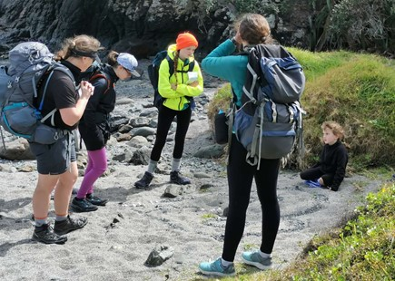
(Replace with your own photo)

DofE Adventurous Journey Report

Name:
Award Level:
Award Unit:

Your Journey Report
At the end of your DofE Qualifying Journey you need to write a report on your journey. This template provides an easy to follow guide for writing your report.

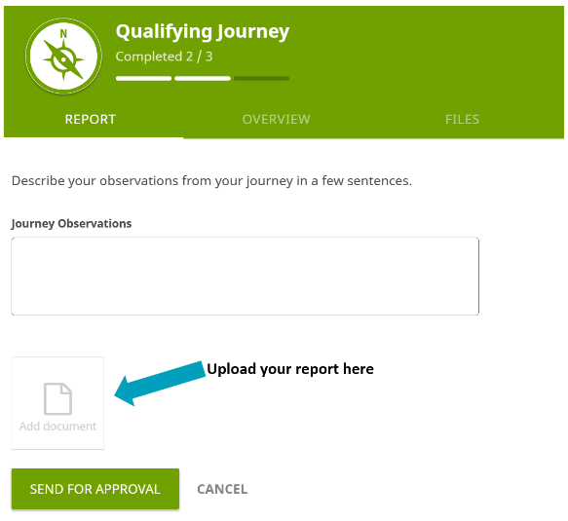
Once you have completed your report upload it to your Online Record Book when you send your qualifying journey for signoff.

What to include in your report
Feelings about the trip – such as what you and the group learnt about yourselves and what were the highs and lows of the trip? What didn’t you like or enjoy? · What were the most memorable events/things you encountered on your journey? · How did your group work together? What were the benefits and problems? · What did you learn? · What were your proudest achievements during the journey? · What was most challenging about this journey? · What would you do differently next time? · What advice would you give to someone before they went on a similar journey?

For more information about writing your report, have a look at our information available on ACORN: https://acorn.aucklandchallenge.org.nz or scan the QR code

Release
I give permission for parts of my report to be used by Auckland Challenge: y / n

Requirements for your Adventurous Journey
Your journey MUST meet all the following requirements
- All journeys must have a clearly defined aim.
- The group size for all journeys must be between 4-7 members (who should be people of a similar age). All participants must have completed suitable training and have the appropriate skills to undertake the journey.
- All participants must have undergone suitable training to have the appropriate skills confidently to undertake their journeys.
- All members of the group must be involved with the planning and preparation of both their Practice and Qualifying Journey.
- All participants must undertake at least one Practice Journey per level prior to the Qualifying Journey.
- All participants must use the same mode of travel for their Qualifying Journey that they did for their Practice Journey. Participants must use a mode of travel that requires their own effort.
- The environment chosen must be unfamiliar to the participant.
- The suggested minimum hours of purposeful effort are 6 hours for Bronze, 7 hours for Silver and 8 hours for Gold.
- On an Expedition, at least two thirds of the purposeful effort must be spent on journeying with the remainder working towards the overall aim.
- On an Exploration, at least one third of the purposeful effort requirement must be spent journeying with the remainder working towards the overall aim.
- All journeys must be supervised and assessed by suitable and experienced adults (the suitability and experience are determined by your organisation’s Safety Management System).
- Accommodation must be in portable tents or huts.
- All members of the group must carry sufficient food, water and equipment to be self-sufficient throughout the journey.
- All participants must prepare and consume a substantial meal each day.
- On completion of the Qualifying Journey, the team is required to deliver a report to their Assessor. This can be verbal, written, photographic or digital.

Practice Journey Summary

Practice Journey Date(s):
Location:
Mode of journeying (hiking, kayaking, cycling etc.)
What did you do for your Practice Journey?

Qualifying Journey

Qualifying Journey Date(s):
Location:
Level:
Mode of journeying (hiking, kayaking, cycling etc.):

What was the purpose that you chose for your journey? What SMART goals did you have?

Who was in your group?

My Daily Recount

Write at least a paragraph for each day of the trip.
Ideas: What happened? What did you experience? How did you develop? What did you learn? What were your challenges? What was your food like? Did you have enough food? Did you bring adequate equipment? What was easy? What was difficult? What was funny? What will you always remember?
Day 1 (Bronze / Silver / Gold):

Day 2 (Bronze / Silver / Gold):

Day 3 (Silver / Gold):

Day 4 (Gold):

My Reflections

What was your favourite part about this journey? Why?

What would you do differently next time? Why?

Paste your route map here:

Paste your photos here:

