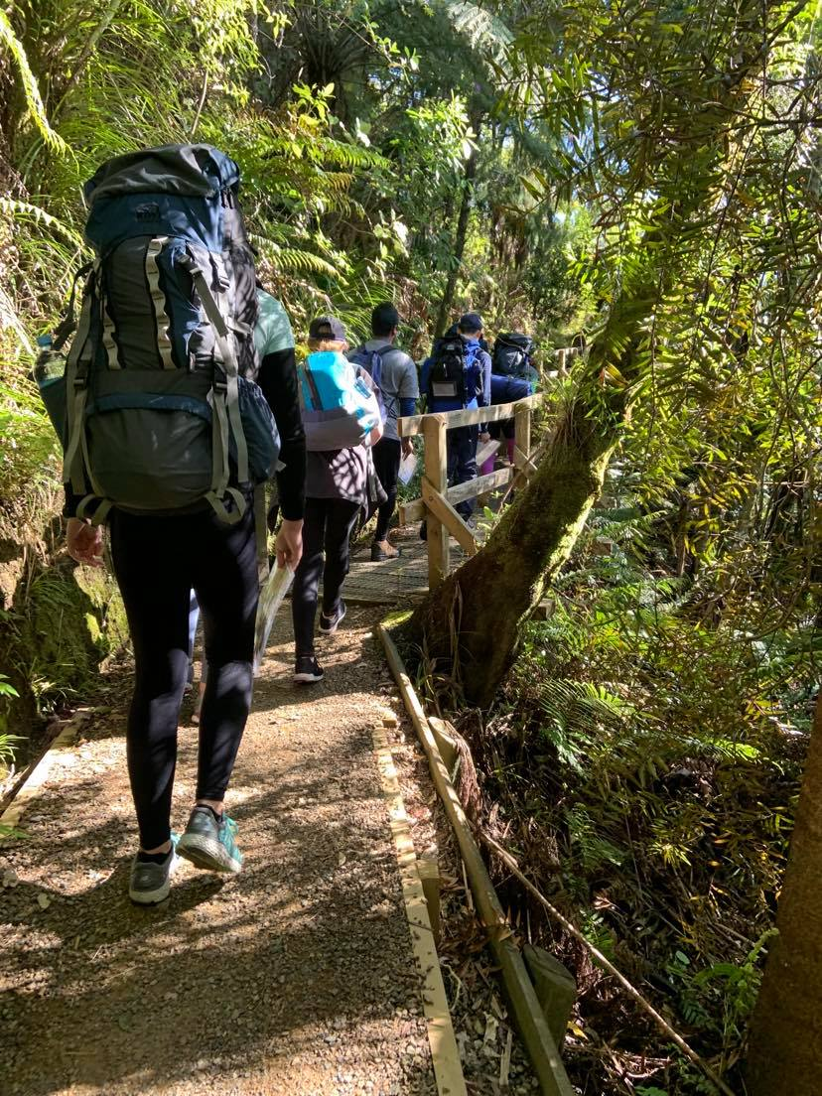
Part 6 | Assessor sops
DofE Journey Planning pack

JPAS401 – Debrief
Complete: Nightly, and at the end of the journey
This SOP should include participants, and the Supervisor
- Gather the participants together. Do this at a dedicated time, not during another activity.
- With the participants and supervisor discuss:
  - What they did that day (or throughout the journey if at the end)
  - Did they learn anything
  - What did they find challenging
  - What did they like
  - What did they dislike
  - Is there anything they would do differently
- Do you or the supervisor have any feedback for the group?
You should aim to keep the debrief light and informal – this is a chance for the participants to discover their experiences.
- At this point the group could start preparing for the next day, see JPPS321

