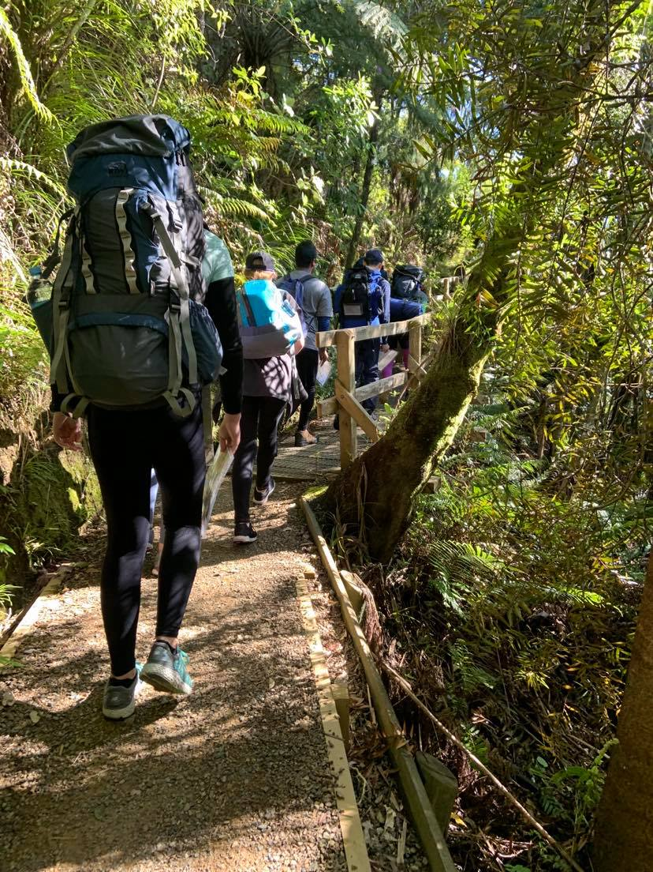
==

Part 8 | Emergency Contact sops
DofE Journey Planning pack

JPES101 – Failure to check in
- Triggers:
  - The group has not made contact by the allocated end-of-journey check in.
  - The group has not made contact by a set check in time.

- Wait 20 minutes for a late check-in.
- Attempt to contact the supervisor.
- Attempt to contact 2 members of the group.
- Wait 15 minutes.
- Repeat 2 & 3
If response: END. If no response: CONTINUE.
- Notify the Award Leader of the authorizing Award Unit. They may provide additional instructions. The Award Leader will notify the National Office based on their SMS.
- Notify the NZ Police on 111 and follow their instructions. Provide details from the group’s plan.
- Notify the emergency contacts of participants. Instruct them not to contact the media or publicize an incident, or to attempt to contact the group.
- Keep the Award Leader informed of developments.

If the group makes contact after notifications have been made

- Immediately notify the Award Leader and NZ Police (if notified).
- Inform the emergency contacts.
AT ALL TIMES:
- DO NOT contact the media.
- DO NOT publicize, announce, or indicate the potential for an incident publicly.
- DO NOT attempt to locate the group yourself or travel to the site

JPES102 – Incident
- Triggers:
  - The group has notified the emergency contact of an incident.

- Collect as much information as possible from the group – write it down. This should include:
  - Best contact method and identifying factors.
  - Current location (grid reference, latitude/longitude, track names)
  - What happened (Is any one injured, missing).
  - Current state of the group (physical and mental).
  - Are emergency services required.
  - Is the group capable of moving if required.
  - What is the group’s plan at this point (evacuate, continue as planned, continue with modifications).
- Advise the group of the actions you are taking e.g. who you are contacting.
- Remain by a communications method for updates.
If emergency services are required
- Call 111, If the journey is urban, request the appropriate service for the incident. If the journey is bush based request police, they will coordinate search and rescue.
- Follow the 111 operator’s instructions and provide them with the information from the group, including relevant medical conditions and items from the journey plan.
- Continue with the remainder of this SOP

- Notify the authorizing Award Leader, they will coordinate with the Award’s National Office. Follow any additional instructions the leader provides you with
- Notify the emergency contacts of any participants directly involved in the incident, Instruct them not to contact the media or publicize an incident, or to attempt to contact the group.
- Notify the emergency contacts of other participants. Instruct them not to contact the media or publicize an incident, or to attempt to contact the group.

Keep the Award Leader, emergency services (if called) and emergency contacts up to date with any developments.

AT ALL TIMES:
- YOU are the primary contact point and relay between the group. All communication is to be relayed through you.
- DO NOT contact the media.
- DO NOT publicize, announce, or indicate the potential for an incident publicly.
- DO NOT attempt to locate the group yourself or travel to the site.

