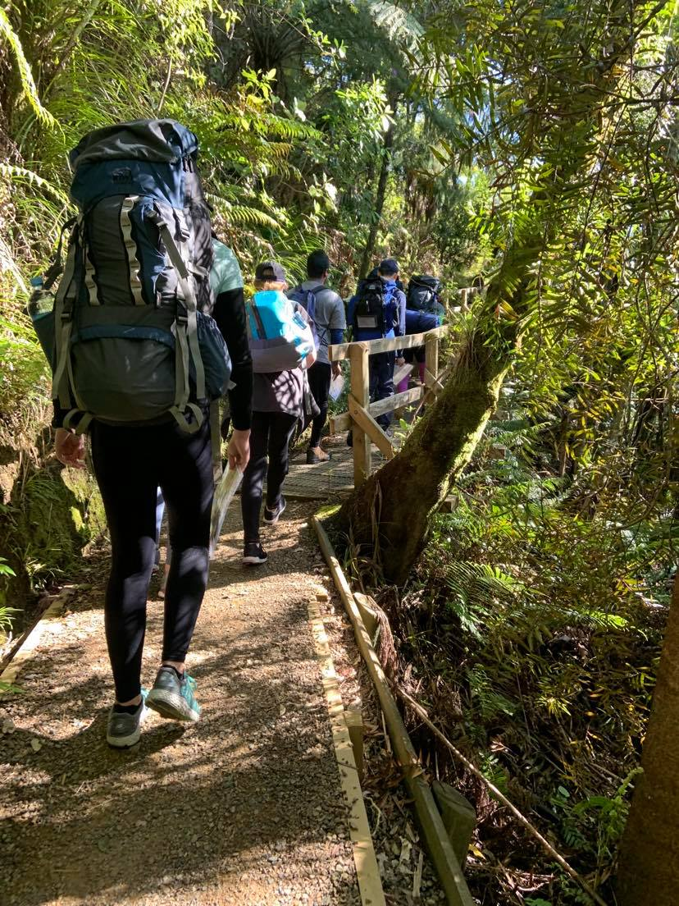
==

Part 10 | authorising award leader sops
DofE Journey Planning pack

JPLS101 – Approval
- Triggers: A journey is submitted for approval

- Check planning paperwork is complete.
- Ensure the planning paperwork is signed off by the Supervisor and Assessor.
- Verify the activities and journey meets Award Requirements and is appropriate to the Award Level.
- Confirm all supervisors meet the minimum competencies (Auckland Challenge Only).
- Ensure all participants have completed training.
- Ensure all participants have entered the journey into the ORB.
If the above criteria are met:
- Sign the approval form in the Journey Plan
- Approve the activities in the ORB
- Store a copy of the Approval form in your Award Unit’s Information Management System
- Auckland Challenge Specific steps
  - Store a copy of the journey plan in Auckland Challenge’s Information Management System (Public/Shared/Journeys/year/date)
  - Enter the Journey Details into Salesforce

JPLS601 – Notification of Incident
- Triggers: The Award Leader is notified of an incident by the Emergency Contact

- Provide the Emergency contact with any additional guidance as required by your Award Unit
- Record as many details about the incident as possible
- NOTIFY the National Award Office if the incident is likely to bring the Award into disrepute or media attention
- NOTIFY any other such governing body such as Board of Directors as required
AT ALL TIMES:
- Follow your Award Unit’s Media plans and policies
- DO NOT travel to the incident
- DO NOT communicate directly with any affected parties – all communication is to be relayed through the group Emergency Contact

JPLS602 – After a journey with an incident
- Triggers: After any journey where there has been an incident

- Review the provided incident notification form
- Debrief with the group and supervisor, include
  - Why the incident occurred
  - What happened
  - What will be done to prevent the incident in the future
- Update any risk registers or similar documents as required
- Notify any external parties as required, specifically:
  - The National Award Office: if the incident may cause harm or media attention to the Award
  - Worksafe: if there has been a notifiable incident
  - Award Unit Board or governing body: as required by Award Unit SMS

AT ALL TIMES:
- Follow your Award Unit’s Media plans and policies
- DO NOT travel to the incident
- DO NOT communicate directly with any affected parties – all communication is to be relayed through the group Emergency Contact

