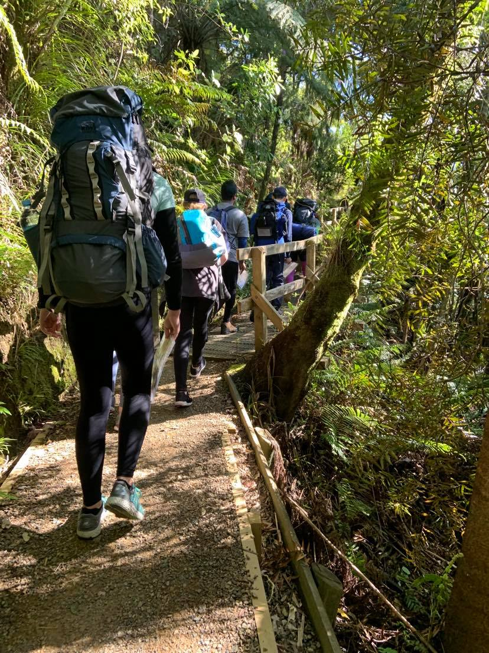
Part 5 | participant sops
DofE Journey Planning pack

JPPS101 – Condition checks
Complete: When required
Depending on your location not all of these steps will be possible, complete as much as possible, or identify alternatives.
- Check the weather forecast, look for:
  - Highs & Lows
  - Rain
  - Wind gusts
  - Weather warnings and watches
- Check for any track or route closures
- Check water conditions (if crossing tidal stream/river)
- Determine if anything needs be altered in your plan as a result of the above, this may include changing routes, remaining at the campsite etc.

JPPS301 – Daily Briefing
Complete: Morning
Include the supervisor in this process
- Check everyone is ready for the day – has everyone eaten
- Check the weather – does the route need altering (JPPS101)
- Check if there are any new injuries or things the group needs to be aware of
- Check everyone is aware of the route for the day
- Check everyone is aware of the risks for the day
- Check everyone has the right gear for the day (exploration)
- Ensure the campsite is clean and tidy

JPPS321 – Review and prepare plan for the following day
Complete: Evening
Include the supervisor in this process
- Gather the group
- (If possible) check the weather forecast for the following day, is it still as you planned?
- Review the planned route for the following day:
  - Are there any changes you need to make due to weather?
  - Is everyone physically capable for the next day – Do you need to adjust based on injuries/fitness?
  - Is there anything else anyone needs to clarify about the route?
- Review the risks for the following day e.g. River crossings
- Ensure everyone knows what timings are being used – When does everyone need to be up, have eaten by etc.

JPPS331 – Campsite checks
Complete: When arriving at a new campsite
- Check the campsite environment for hazards
- Identify nearby facilities (running water, toilet, rubbish bins)
- Choose a common area to set up camp, Consider:
  - Shelter & wind direction
  - Sun
  - Ground conditions
If the campsite is suitable: continue; Otherwise: Locate a safe campsite nearby.
- Identify areas you will use for cooking
- Set up tents
- Check all tents are set up and the campsite is tidy.

JPPS331 – General Travel
Complete: While travelling throughout the journey (non-sequential)
- Keep to marked paths and tracks.
- Stop at junctions and intersections for the group to stay together.
- Check route maps at junctions.
- Take regular breaks when needed by any group member.
- Keep the slowest group member at the front of the group.
- Keep the group together.

