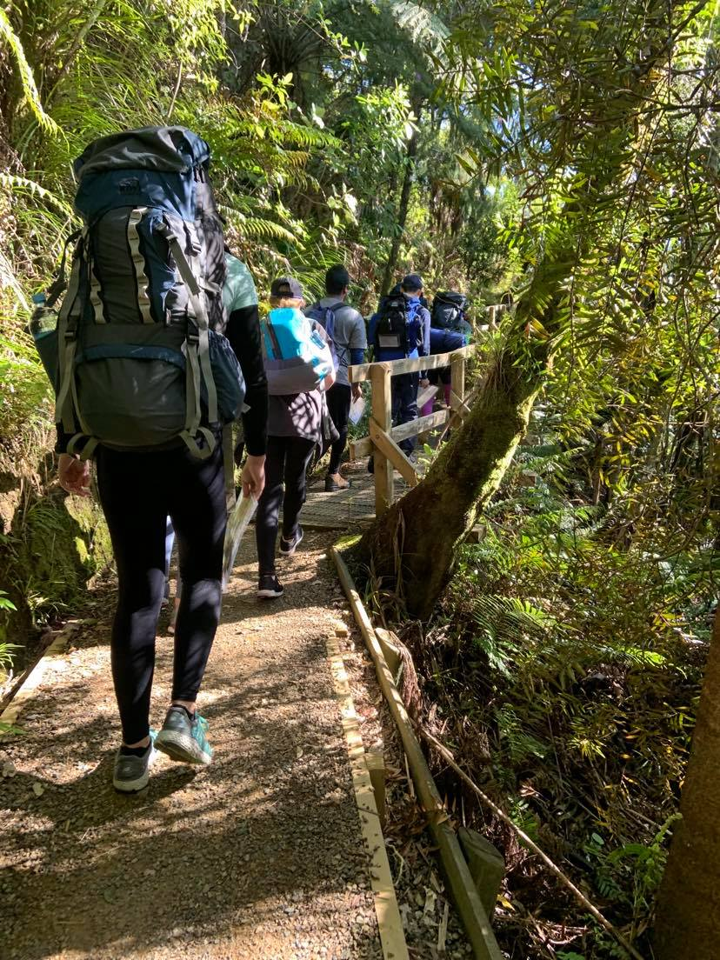

Part 4 | Supervisor sops
DofE Journey Planning pack

JPSS101 – Check planning paperwork is complete
Complete: Before the journey is submitted for approval.
N.B. This SOP should be completed in conjunction with participants.

- Ensure all participants have completed the required training for their Award, or will have done so prior to the start of the journey
- Check each section of the planning paperwork is filled in, and is accurate. Make modifications as required. In particular:
  - Ensure group information is complete and correct. Check a group emergency contact is listed.
  - Ensure weather information is complete (JPPS101)
  - Ensure risk management is complete and identify any further risks the participants may have overlooked
  - Check route cards and maps
  - Check gear list for any additional gear required
- Check emergency contacts
  - Send a message to each emergency contact to check the contact number is correct
  - Update any inaccurate or incorrect information.
- Ensure planned route and activities are suitable for the Award Level of the participants. Check for:
  - Skill level
  - Fitness level
  - Environment
- Adjust any sections that are not suitable or accurate.
- [participants] Complete Assessor Signoff
- [participants] Complete Award Leader Signoff
- If you are satisfied with the journey, and that it meets requirements sign the supervisor approval. Otherwise advise the participants on the required changes
- [participants] Enter the journey into the ORB for approval.

JPSS201 – Gear check and briefing
Complete: Start of the journey

- Before the journey has begun the supervisor must ensure they have they appropriate equipment for the journey in accordance with the standard gear list and activity specific gear.
- As participants are dropped off confirm with guardians details for pickup at the end of the journey. It is advised guardians remain until the participants begin travelling.
- Confirm with participants their medical details and emergency contact details, update where necessary.
- Confirm all participants have completed training for their Award Level. If not, they are to be sent home.
- Confirm participants are comfortable to begin the journey (mentally, physically)
Once all participants are present
- All participants are to unpack their packs
- Work through each item on the planned gear list, get participants to show you that item. Ensure all items are appropriate to the journey i.e. no cotton/denim etc.
If a participant does not have an item
- Determine if the item is essential for the trip. if not: continue.
- If it is essential, can the participant share this equipment? Or is it possible for it to be dropped off before it is needed? If so: continue; Otherwise the participant cannot continue with the journey and should be sent home.

- All participants are to repack their packs
- Guardians can be sent home at this point.
- Discuss with participants the plan and route for that day, complete JPPS301

JPSS321 – Cooking Procedures
Complete: Whenever participants are cooking
- Ensure the cooking participants have made other participants aware of their actions
- Monitor the cooking participants at all times, do not leave the cooking site
- Ensure participants are positioned appropriately, and are not wearing loose or flammable clothing
- Ensure participants are not cooking near tents, foliage, or unsuitable ground conditions
- Make a note of the nearest water supply (See JPPS331)
- Provide guidance and advice to participants who need it
- Direct participants to stop cooking if the environment becomes unsafe.

JPSS331 – River crossing
Complete: Before, during and after any river crossing
- Stop the group before entering the river
- Check the river conditions:
  - Flow rate
  - Swells
  - Depth
  - Upstream debris
DO NOT CROSS IF: the river is flowing faster than walking speed, is likely to be above waist height, there is large debris in the water, there has recently been heavy rain, any other condition you deem unsafe. Instead use your alternative route.
- Ensure all people crossing the river have gear waterproofed, and remove any loose items
- Remove any items of clothing that shouldn’t get wet
- Ensure no one has chest straps done up, and pack straps are loosened
- Cross the river in groups of 2-6 people with the following structure
  - All persons interlinked around the back, holding the opposing pack strap
  - The strongest person upstream
  - Travel in a parallel line to the current
  - At no point should any person cross the river alone
  - Keep boots on
- Do not attempt to grab any equipment floating away.
- After crossing the river
  - Participants should replace wet clothes

JPSS332 – Supervisor positioning and ratios
Complete: At all times throughout the journey
- For all outdoor activities there is a maximum ratio of 7 participants to one supervisor.
- The above ratio may be lowered if deemed necessary for the journey activity
- As all journeys are designed to be participant led, the supervisor should remain at the back of the group. For Silver or Gold level journeys the supervisor may stay behind the group to allow independence however they MUST always be within sight and earshot of the group as to prevent incident.
- At no point during the journey, except while sleeping, or where privacy is expected should any participant be alone. There must always be a minimum of two participants together at all times.
- At any point if the journey becomes hazardous to the group or environment or meets the criteria to halt an activity according to Auckland Challenge’s Safety Management System immediately stop the group and begin corrective action or evacuation as required.

JPSS601 – Incident Management
Complete: During any incident
- Stop the group
- Assess the incident to decide on further actions, this should consider
  - Injuries
  - Is the group capable of moving
  - Could the situation worsen
  - Is anyone lost/missing
- Follow JPSS602 in addition to this SOP

If the incident can be handled without outside help
- Decide if the group will need to evacuate, or whether the journey will continue with minor modifications.

If the group is evacuating
- Notify the emergency contact of your intentions as soon as possible.
- Evacuate using the nearest planned exit route
If the group is continuing with modifications
- Handle the incident as needed.
- Record any details leading to the incident.

If the group requires external emergency assistance
- Contact 111, for emergency medical incidents ask for Ambulance, for lost or missing persons ask for Police.
- Follow any directions of the 111 operator.
- Notify the Award Leader of the Authorizing Award Unit as soon as practical.

AFTER THE JOURNEY ENDS
- Debrief the incident with the group.
- Complete an incident notification from.
- Provide the incident notification form to the Award Leader of the Authorizing Award Unit.
- Debrief with the Authorizing Award Unit’s appointed staff.

JPSS602 – Incident Management – Specific circumstances
Complete: During any relevant incident

If a person is lost or missing
- Stop the group.
- Return to the previous junction (if less than 750 meters away, bush only).
- Use a whistle or other signaling/communication method e.g. phone, radio as appropriate to the journey environment.
- Remain at the current location, do not split up.
- Notify the emergency contact after no more then 30 minutes.

If you need to send someone to get help or reach a communications method
- Collect as much information as possible about the incident
- Send people to go for help, no person should be left alone, there should be a minimum of two people together at all times.
- Set a time at which the people who have gone for help to check in
- Set a maximum distance and route that the people will follow

