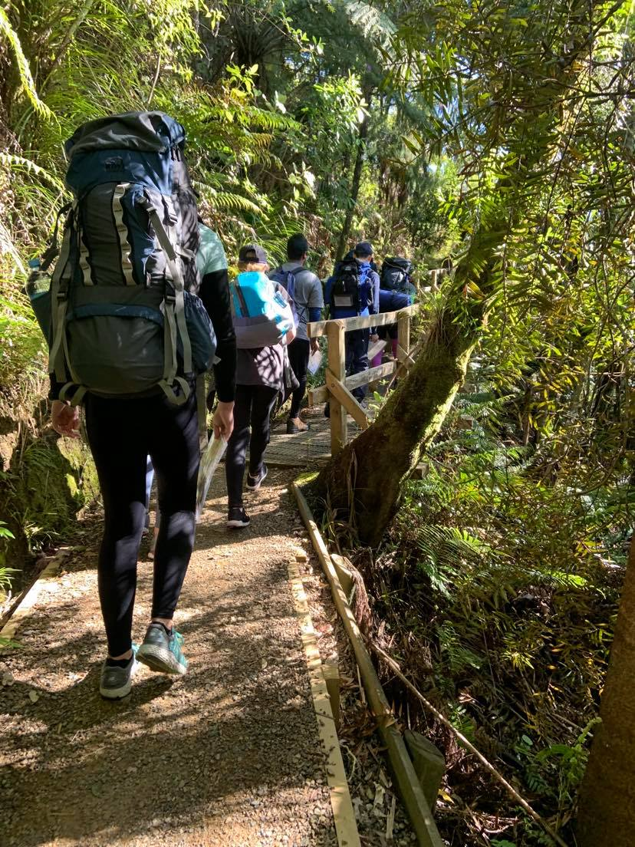
Part 3 | Checklists
DofE Journey Planning pack

Planning _{(JPxS1xx)}

Supervisor
- Check participants have suitable training. (Award training for their level + additional training for the activity)
- Check planning paperwork is completed (JPSS101).
- Condition Checks (JPPS101)
- Check that all participant consent forms have been received. (Complete police vetting if required)

Assessor
- Check Award Requirements are met

Participants
- Condition Checks (JPPS101)
- Check planning paperwork is completed (JPSS101).

Authorizing Award Leader
- Approval (JPLS101)

Start of Journey _{(JPxS2xx)}

Supervisor
- Condition checks (JPPS101)
- Gear check and Briefing (JPSS201)
- Safety briefing for group

During Journey _{(JPxS3xx)}

Morning
- Daily briefing (JPPS301)

Supervisor
- Daily briefing (JPPS301)

Evening

Supervisor
- Cooking (JPSS321)
- Debrief (JPAS401)

Assessor
- Debrief (JPAS401)

Participants
- Review and prepare plan for following day (JPPS321)

General

Supervisor
- River Crossing (JPSS331)

Participants
- Campsite Check/review (JPPS331)
- General travel (JPPS332)

End of Journey _{(JPxS4xx)}

Supervisor
- Debrief (JPAS401)

Assessor
- Debrief (JPAS401)

After Journey _{(JPxS5xx)}

Participants
- Complete Journey report

General SOPs _{(JPxS6xx)}

Supervisor
- Incident Management (JPSS601).

Authorizing Award Leader
- Notification of Incident (JPLS601)
- After a journey with an incident (JPLS602)

All
- Communications (JPGS101)

